Cognitive Aging Data Protocols

Downloading Data from Redcap:

* Ensure that export settings are as follows:

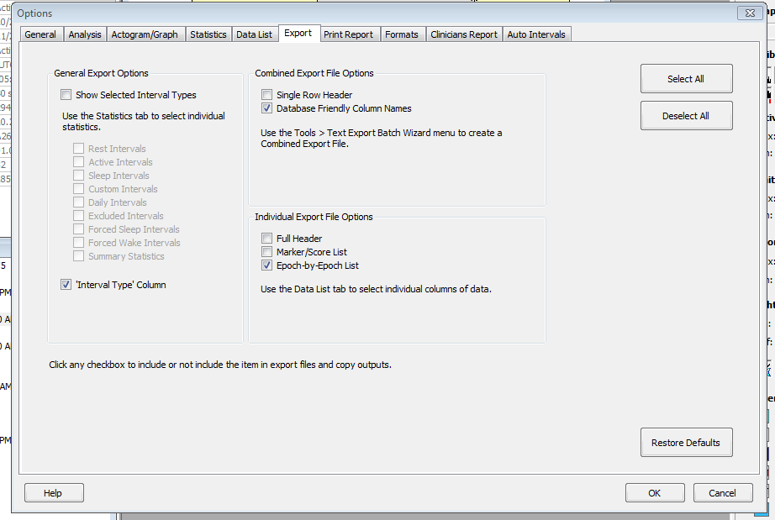

* When exporting, make if any subjects have duplicate data, only the first (shorter) data analysis is selected for export. Example:

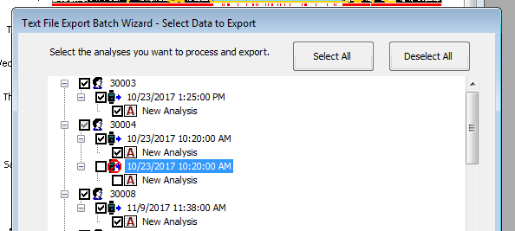

To “Clean” data:

* Put data exported from redcap into a folder labeled “old” within C:\Users\memlab\Desktop\actigraphData_Aging
* Put newest survey data in C:\Users\memlab\Desktop\actigraphData_Aging
  + Download this data to a raw csv from redcap
  + Must contain columns labelled ‘record_id’ and ‘actigraph_off’
* Ensure that the “new” folder within C:\Users\memlab\Desktop\actigraphData_Aging is empty
* Obtain newest version of AgingActigraphScript.py from:
  + <https://github.com/henryrossiter/CogNeuro/tree/master/actigraphData_Aging>
* Run this python script within C:\Users\memlab\Desktop\actigraphData_Aging
* Cleaned files will be output to folder labeled “new”
* For questions, email [henry.rossiter@utexas.edu](mailto:henry.rossiter@utexas.edu)